Vector Stores in LangChain
https://www.youtube.com/watch?v=k13WK0bxQP0&list=PLKnIA16_RmvaTbihpo4MtzVm4XOQa0ER0&index=14
https://colab.research.google.com/drive/1VwOywJ9LPSIpKWKj9vueVoexSCzGHXNC?usp=sharing
00:00 - Intro
00:59 - Why Vector Stores?
18:32 - What are vector Stores?
28:50 - Vector Store vs Vector Database
33:44 - Vector Stores in Langchain
37:05 - Chroma Vector Store & Code
Vector Stores in LangChain – Complete Documentation

1. Introduction to Vector Stores
In this video, we continue learning the important components required to build RAG (Retrieval-Augmented Generation) based applications using LangChain.
So far, we have already covered:
- Document Loaders
- Text Splitters
Now, we move to another critical component of RAG:
👉 Vector Stores
The plan of this video is:
- Understand why vector stores are needed
- Learn what vector stores are
- Explore their core features
- Understand real-world use cases
- See how vector stores are used in LangChain (later in the video with code)
Vector stores play a very important role in building semantic search and RAG systems.

2. Why Do We Need Vector Stores?
To understand the need for vector stores, let’s go through a real-world example.

2.1 Example: Building a Movie Catalog Website
Imagine you want to build a website like IMDb where:
- All movies in the world are listed
- Users can search any movie
- Users can view full movie details
Your system would typically include:
- A database storing movie information:
  - Movie ID
  - Movie name
  - Director
  - Actors
  - Genre
  - Release date
  - Hit or flop status
- A backend (for example in Python) to fetch data
- A frontend to display data
This is a traditional web application structure.
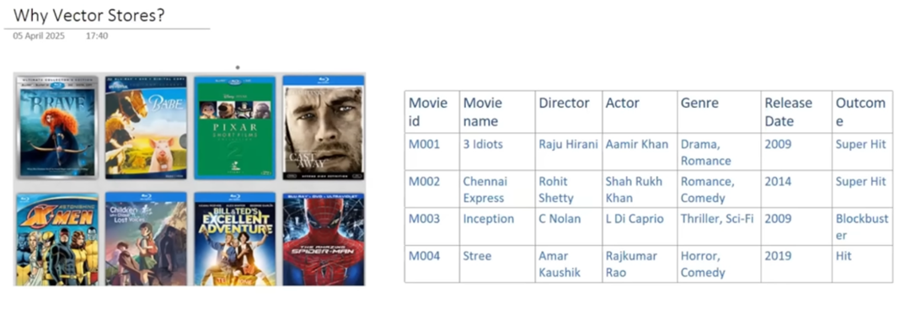

2.2 Adding a Movie Recommendation System
Now you want to improve the website by adding a movie recommendation system.
Example:
When a user opens the page of Spider-Man, the system should suggest:
- Iron Man
- Captain America
- Similar movies
This increases:
- User engagement
- Time spent on the website
- Revenue from ads

2.3 Simple Approach: Keyword Matching
A basic way to build recommendations is:
Compare movies based on:
- Director
- Actor
- Genre
- Release year
If many keywords match → movies are considered similar.
This method is simple and sometimes works.

2.4 Problem with Keyword Matching (Flaws)
Example 1: Wrong Recommendations
User watched:
👉 My Name Is Khan
System recommends:
👉 Kabhi Alvida Na Kehna
Why?
Because keywords match:
- Same director (Karan Johar)
- Same actor (Shah Rukh Khan)
- Similar genre (drama)
But:
- Storylines are completely different
- Emotion and theme are not similar
So recommendation is poor.

Example 2: Missing Good Recommendations
Movies:
👉 Taare Zameen Par
👉 A Beautiful Mind
Both movies are about:
- A central character struggling with a problem
- But being brilliant in some way
So they are thematically similar.
But:
- Directors are different
- Actors are different
- Release times are different
Keyword matching finds no similarity.
So system fails again.

2.5 Conclusion from This Problem
Keyword matching:
- Is too simple
- Does not understand meaning
- Produces poor quality recommendations
We need a smarter approach.

3. Better Approach: Comparing Movie Plots (Semantic Meaning)
Instead of comparing keywords, we should:
👉 Compare the story (plot) of movies
If two movies have similar plots:
→ They are similar movies.

3.1 Updating the Database
Now we collect:
- Movie ID
- Movie name
- Full movie plot (2000–3000 words)
So each movie has a large text description.
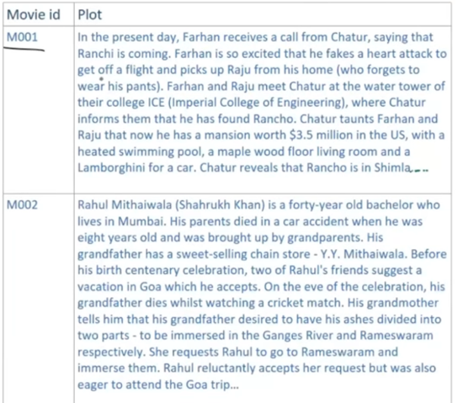

3.2 New Goal
We want a system that:
- Compares movie plots
- Generates a similarity score
- Recommends movies with highest similarity

4. Using Embeddings to Represent Meaning
Comparing raw text is very difficult.
But deep learning solved this using:
👉 Embeddings

4.1 What Are Embeddings?
Embeddings are a technique that:
- Converts text into numbers (vectors)
- These numbers represent semantic meaning
Process:
- Take a piece of text (movie plot)
- Send it to a neural network
- Network outputs a vector (like 512 dimensions or more)
Each vector captures the meaning of the text.
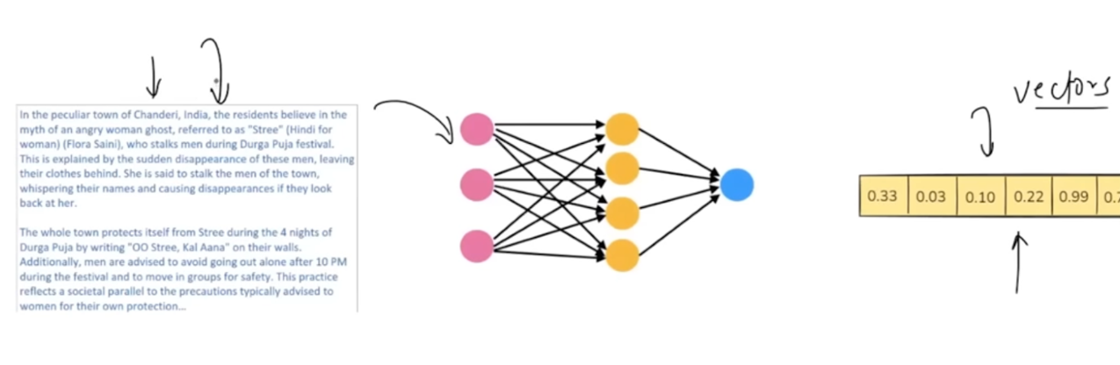

4.2 Example
Each movie plot becomes:
- Vector M1
- Vector M2
- Vector M3
- Vector M4
Each vector has hundreds of numerical values.

5. Finding Similar Movies Using Vectors
Once all movie plots are converted to vectors:
- We place them in high-dimensional space
- Then compute similarity using:
👉 Cosine similarity (angular distance)
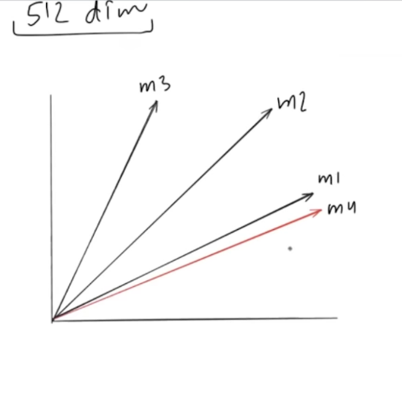

5.1 How It Works
- Smaller angle between vectors → more similar meaning
- Larger angle → less similar
Example:
If vector M4 is closest to M1:
→ Movie 4 is most similar to Movie 1

5.2 Final Recommendation Flow
- Collect movie plots
- Convert to embeddings
- Store embeddings
- Compute similarity
- Recommend closest movies

6. Challenges in Building This System
While the idea is great, there are major challenges:

6.1 Challenge 1: Generating Embeddings at Scale
If you have:
- Millions of movies
You must:
- Generate embeddings for each movie
This is expensive and heavy.

6.2 Challenge 2: Storing Embeddings
Embeddings:
- Are large vectors
- Cannot be efficiently stored in traditional databases like:
  - MySQL
  - Oracle
Relational databases do not support vector similarity search.
We need specialized storage.

6.3 Challenge 3: Fast Semantic Search
If you have:
- 1 million vectors
And want to find:
- Top 5 similar vectors
Naively comparing with all 1 million:
- Is extremely slow
- Makes application unusable
We need smart search algorithms.

7. Solution: Vector Stores
All these challenges are solved by:
👉 Vector Stores

8. What Are Vector Stores?
Definition:
A Vector Store is a system designed to:
- Store data represented as numerical vectors
- Retrieve vectors efficiently
- Perform similarity search
In simple words:
If your application works with embeddings (vectors), you use a vector store.

9. Core Features of Vector Stores
There are four main features.
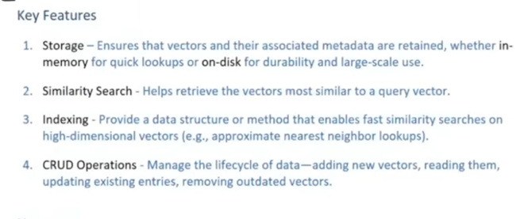

9.1 Storage
Vector stores allow you to store:
- Embeddings (vectors)
- Associated metadata (extra info)
Example metadata:
- Movie ID
- Movie name
Storage options:
- In-memory (RAM)
  - Fast
  - Not persistent
- On-disk (database / file system)
  - Persistent
  - Used in production

9.2 Similarity Search
Vector stores provide built-in methods to:
- Compare query vector with stored vectors
- Return most similar vectors
This is used for:
- Recommendations
- Semantic search
- RAG retrieval

9.3 Indexing for Fast Search
Instead of brute-force comparison, vector stores use:
- Smart indexing techniques
Example method:
👉 Clustering
Process:
- Group vectors into clusters
- Compute centroid for each cluster
- Compare query vector only with centroids
- Search inside closest cluster
This reduces:
- From millions of comparisons
- To thousands only
Common techniques include:
- Approximate Nearest Neighbor (ANN)
This makes search extremely fast.
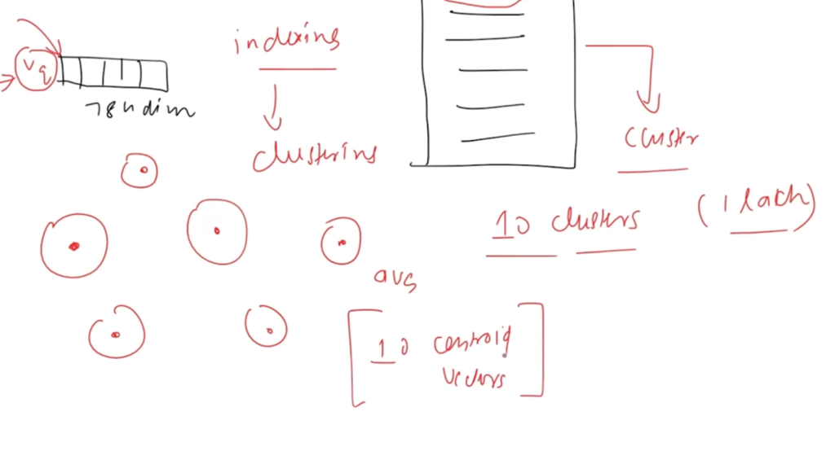

9.4 CRUD Operations
Vector stores also support:
- Create (add vectors)
- Read (retrieve vectors)
- Update
- Delete
Just like traditional databases.

10. Common Use Cases of Vector Stores
Vector stores are used in:
- Recommendation systems
- Semantic search engines
- RAG (Retrieval-Augmented Generation)
- Image and multimedia search
- Any application using embeddings

11. Why Not Use Traditional Databases?
Relational databases:
- Are great for tables and structured data
- Are not designed for:
  - High-dimensional vectors
  - Similarity search
Vector stores are built specifically for this purpose.

12. Summary So Far
Vector Stores:
- Store embeddings efficiently
- Allow fast semantic search
- Use indexing for performance
- Support metadata and CRUD
They are essential for:
- RAG systems
- Recommendation engines
- AI-powered search

13️. Vector Store vs Vector Database
Concept Clarification:
- In LangChain and other AI frameworks, the terms vector store and vector database are often used interchangeably online.
- Beginners often find this confusing, so the distinction is important for understanding system design.
Vector Store:
- A vector store is a lightweight system primarily providing two core functions:
  - Storage: Store embeddings (vectors) efficiently.
  - Retrieval: Perform semantic similarity search on vectors.
- If a system only provides these functions, it is called a vector store.
- Characteristics:
  - Typically a lightweight library or service.
  - Does not include traditional database features:
    - Transactions
    - Rich query languages (SQL)
    - Role-based access control
    - Authentication or advanced security
  - Ideal for prototyping and small-scale applications.
- Example: FAISS (Facebook AI library)
Vector Database:
- A vector database is essentially a vector store + additional database features.
- Additional database-like features may include:
  - Distributed architecture → enables large-scale horizontal scaling.
  - Backup and restore → ensures data durability.
  - Transactions & concurrency control → supports multiple users simultaneously.
  - Authentication & authorization → provides advanced security.
- Designed for production environments and large datasets.
- Examples: Milvus, Weaviate, Pinecone, Quadrant
Key Takeaway:
- Every vector database is a vector store, but not every vector store is a vector database.
- Adding database-like features to a vector store converts it into a vector database.

14️. Vector Stores in LangChain
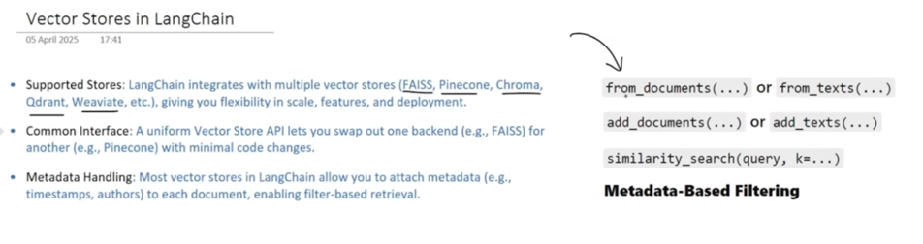
LangChain Design Philosophy:
- LangChain was built with future LLM applications in mind, where embeddings and semantic search are essential.
- Since almost every LLM-based application uses vector embeddings, support for vector stores and databases was provided early on.
Supported Vector Stores:
- LangChain provides built-in components (wrappers) for all major vector stores:
  - Pinecone
  - Chroma
  - Weaviate
  - Quadrant
- These wrappers allow developers to interact with different vector stores using the same method names.
Unified Interface:
- Common methods across all vector stores:
  - from_documents / from_texts → create a vector store from documents or text.
  - add_documents / add_texts → add new vectors.
  - similarity_search → perform semantic search.
  - metadata filtering → search based on metadata.
- Benefit: You can swap one vector store for another (e.g., FAISS → Pinecone) without changing your existing code, because the methods are consistent across stores.
Next Step (Practical):
- Use Chroma DB to:
  - Create a vector store
  - Add new documents
  - Delete old documents
  - Perform similarity search
- This demonstrates LangChain’s unified approach for managing multiple vector store types.

15️. Chroma Vector Store & Implementation in LangChain
Introduction to Chroma DB
- Chroma DB is a lightweight, open-source vector database.
- Suitable for:
  - Local development
  - Small to medium-scale production use
- Key points:
  - Acts between a vector store and a full-fledged vector database:
    - More features than a simple vector store
    - Lighter than other vector databases like Pinecone
  - Provides a flavor of both worlds:
    - Some database features
    - Lightweight and simple enough for smaller projects
Data Organization in Chroma DB
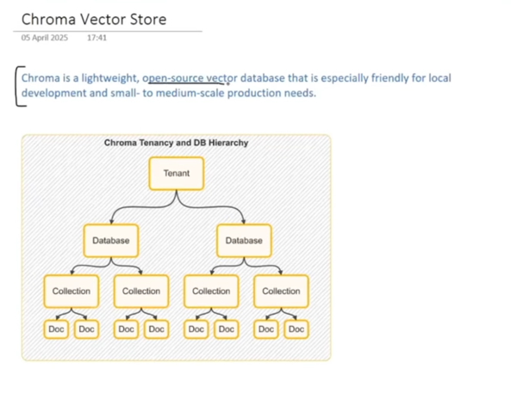
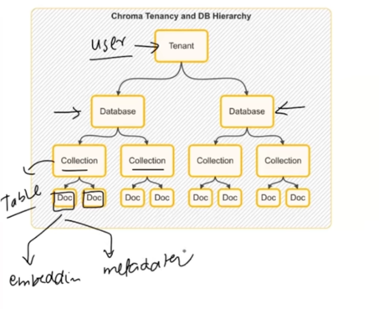
- Tenant (Top Level):
  - Represents a user, team, or organization
  - Each tenant can create multiple databases
- Database Level:
  - Inside a database, you can create multiple collections
  - A collection is equivalent to a table in RDBMS
- Collection Level:
  - Each collection stores multiple documents
  - Document structure:
    - Embedding vector: Represents the semantic representation of text
    - Metadata: Additional info about the vector/document
  - This hierarchical structure keeps Chroma DB organized and scalable

Using Chroma with LangChain
Operations possible using LangChain:
- Create a new collection
- Add new documents
- Update existing documents
- Delete documents
- Perform semantic similarity search
- Apply metadata-based filtering
Key Benefit:
- If you learn Chroma DB, you can easily switch to FAISS, Pinecone, Weaviate, etc., with minimal changes in code due to consistent interface methods in LangChain.

Implementation Example in Google Colab
Step 1: Install Required Libraries
!pip install chromadb langchain openai
Step 2: Import Libraries
from langchain.embeddings import OpenAIEmbeddings
from langchain.vectorstores import Chroma
- Can similarly import other vector stores (FAISS, Pinecone, Weaviate)
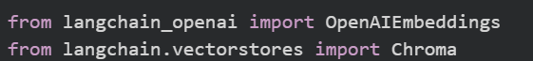

Step 3: Create Document Objects
- Each document has:
  - page_content → Actual text
  - metadata → Related information
Example: Cricket Players
from langchain.schema import Document
doc1 = Document(page_content="Virat Kohli is a former RCB captain.", metadata={"team": "RCB"})
doc2 = Document(page_content="Rohit Sharma plays for MI.", metadata={"team": "MI"})
doc3 = Document(page_content="MS Dhoni is known for leadership.", metadata={"team": "CSK"})
doc4 = Document(page_content="Jasprit Bumrah is a fast bowler.", metadata={"team": "MI"})
doc5 = Document(page_content="Ravindra Jadeja is an all-rounder.", metadata={"team": "CSK"})
docs = [doc1, doc2, doc3, doc4, doc5]
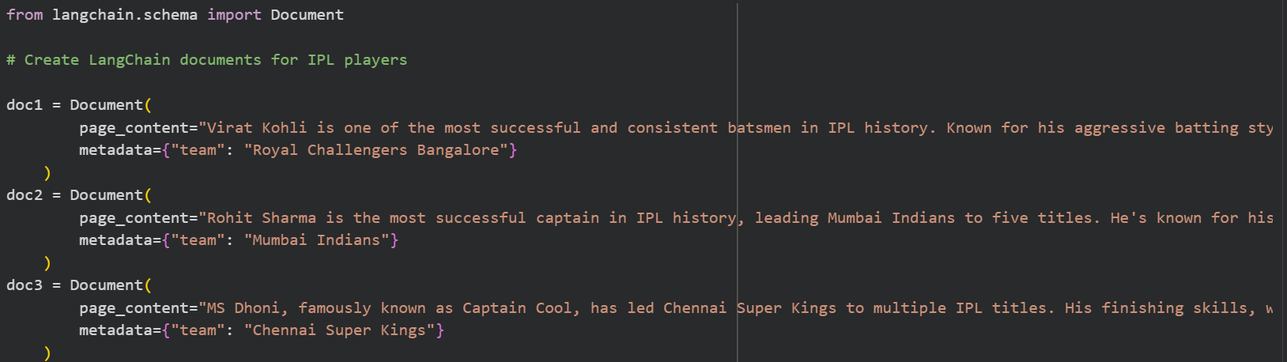


Step 4: Create Chroma Vector Store
- Persist directory: Stores all embeddings in SQLite format
- Collection: Equivalent to a table
- Embedding function: Converts documents to vectors before storage
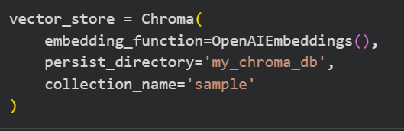

Step 5: Add Documents
- Each document gets a unique ID (auto-generated)
- You can view documents, embeddings, metadata using vectordb.get()
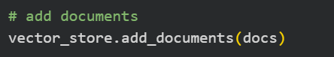
View the documents
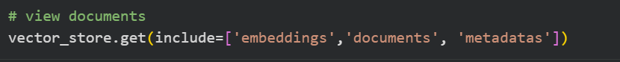
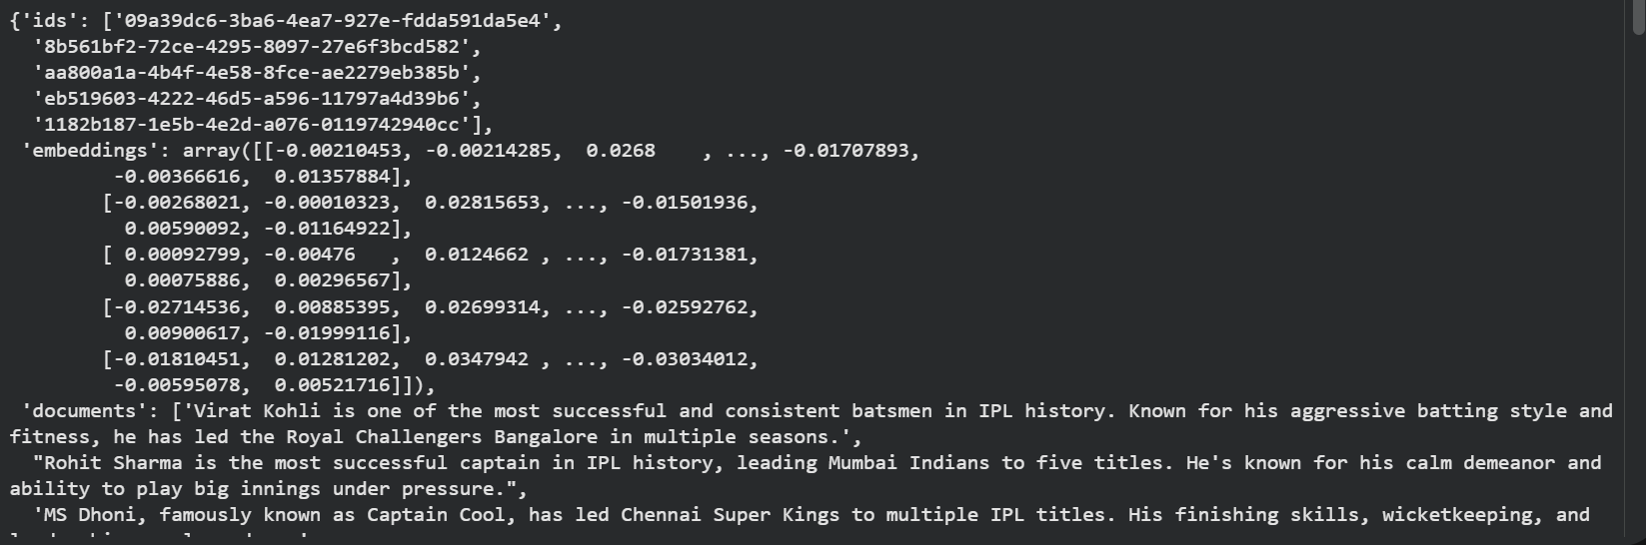

Step 6: Perform Similarity Search
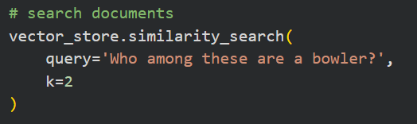
- Returns the most semantically similar document
- K parameter specifies how many top results to return
With Score:
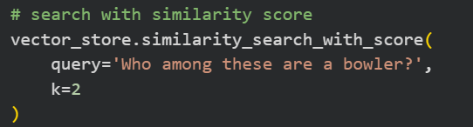
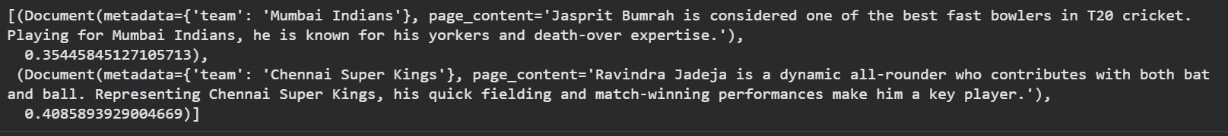
- Returns similarity score alongside documents
- Lower distance = more similar

Step 7: Metadata Filtering
# Filter players by team "CSK"
filtered_results = vectordb.similarity_search(
query="",
k=10,
filter={"team": "CSK"}
)
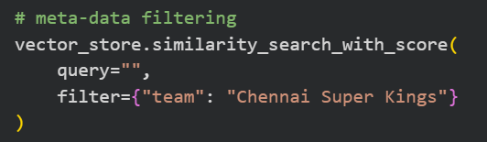
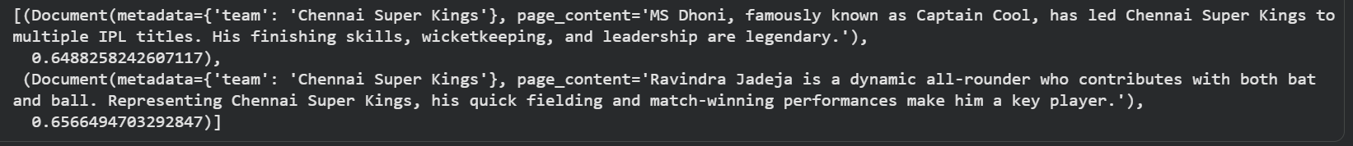
- Useful for narrowing results based on metadata

Step 8: Update Existing Document
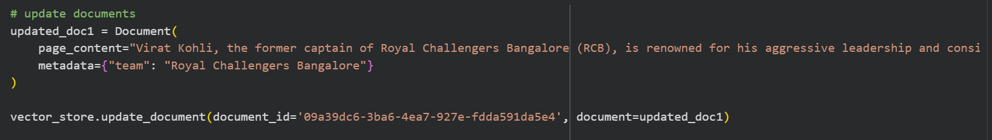
- Updates the content of an existing document using its document ID
View after editing
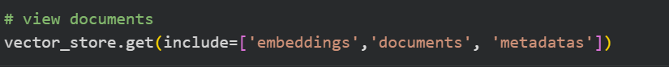

Step 9: Delete Document
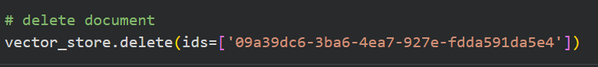
- Removes document from the vector store
- Check remaining documents using get() method
View after deleting

Summary of Operations
Operation | Function Used
Create vector store | Chroma(...)
Add documents | add_documents()
View documents | get()
Semantic search | similarity_search()
Semantic search + score | similarity_search_with_score()
Metadata filtering | similarity_search(filter={...})
Update document | update_document()
Delete document | delete_documents()

Key Takeaways
- Chroma DB is a lightweight vector database, between a vector store and a full-fledged database.
- Supports:
  - Embeddings storage
  - Semantic search
  - Metadata-based filtering
  - Update and delete operations
- LangChain provides a common interface, making it easy to switch vector stores like FAISS or Pinecone.
- Ideal for local development, prototyping, and small to medium-scale production projects.

